PROTECT AND IMMUNIZE NEVADA’S NEWBORNS (PINN)
The Protect and Immunize Nevada’s Newborns (PINN) packet is a collection of information and resources covering a range of topics, including immunizations, childcare, safety, and more. It was crafted with the goal of helping Nevadans to make informed decisions that promote the health of all families.
If you have any questions or need additional resources, please feel free to contact or visit us online at Nevada State Immunization Program and Maternal, Child and Adolescent Health (MCAH). If you need additional resources not listed in this packet, please visit Nevada 211 or call 2-1-1 or 1-866-535-5654. You can also text Nevada 211 by texting your zip code to 898211 or chat with a specialist on their website or app.

All in good health,

Nevada State Immunization Program
Division of Public and Behavioral Health

“This publication was supported by the Nevada State Department of Health and Human Services through Funds for Healthy Nevada from the State Treasury. Its contents are solely the responsibility of the authors and do not necessarily represent the official views of the Department nor the State Treasury.”

Table of Contents
Car Seat Safety 3
Cribs For Kids 5
Cytomegalovirus (CMV) 7
FIRST 5 NEVADA 8
Heatstroke Safety 9
Lead Exposure 10
Look Before You Lock! 11
Maternal Hotline 12
MCH Coalition 13
Nevada Breastfeeds 14
Nevada Children’s Medical Home Portal 15
Nevada PRAMS 16
Nevada WebIZ Public Access Portal 17
Post-Birth Warning Signs 18
Recommended Vaccinations 19
RSV- Infants and Young Children 21
Sober Moms, Healthy Babies 22
Vaccines for Children (VFC) 23
Water Safety Tips for New Parents 24
WIC 25
Additional Resources 26

Car Seat Safety
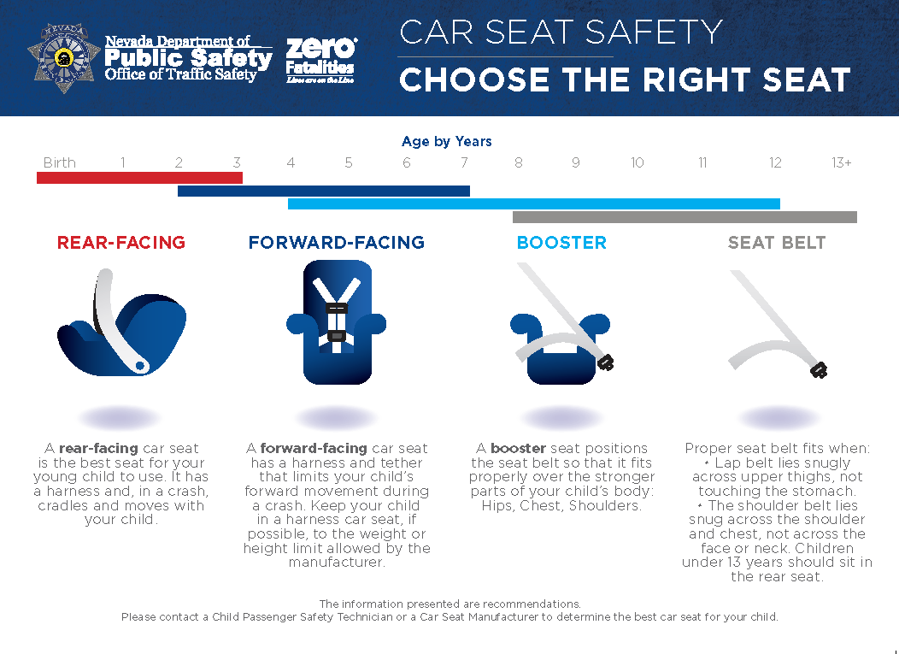

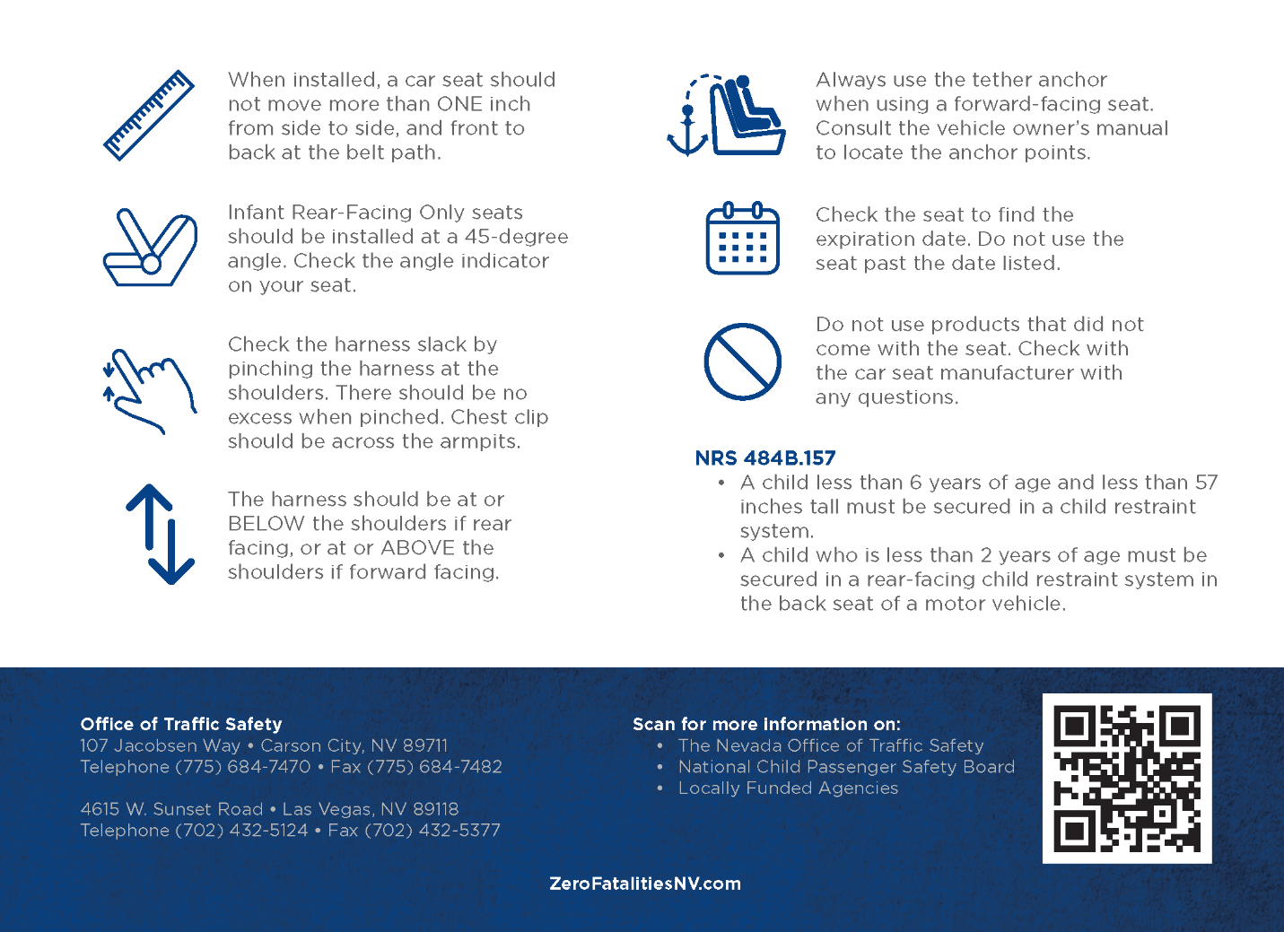

Cribs For Kids

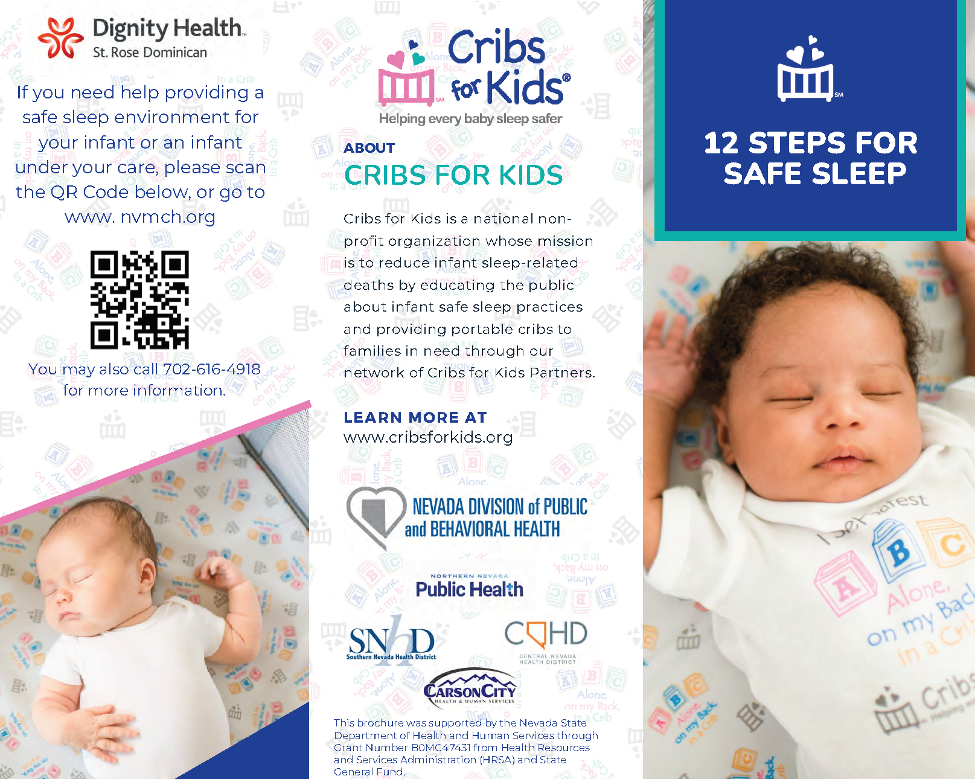

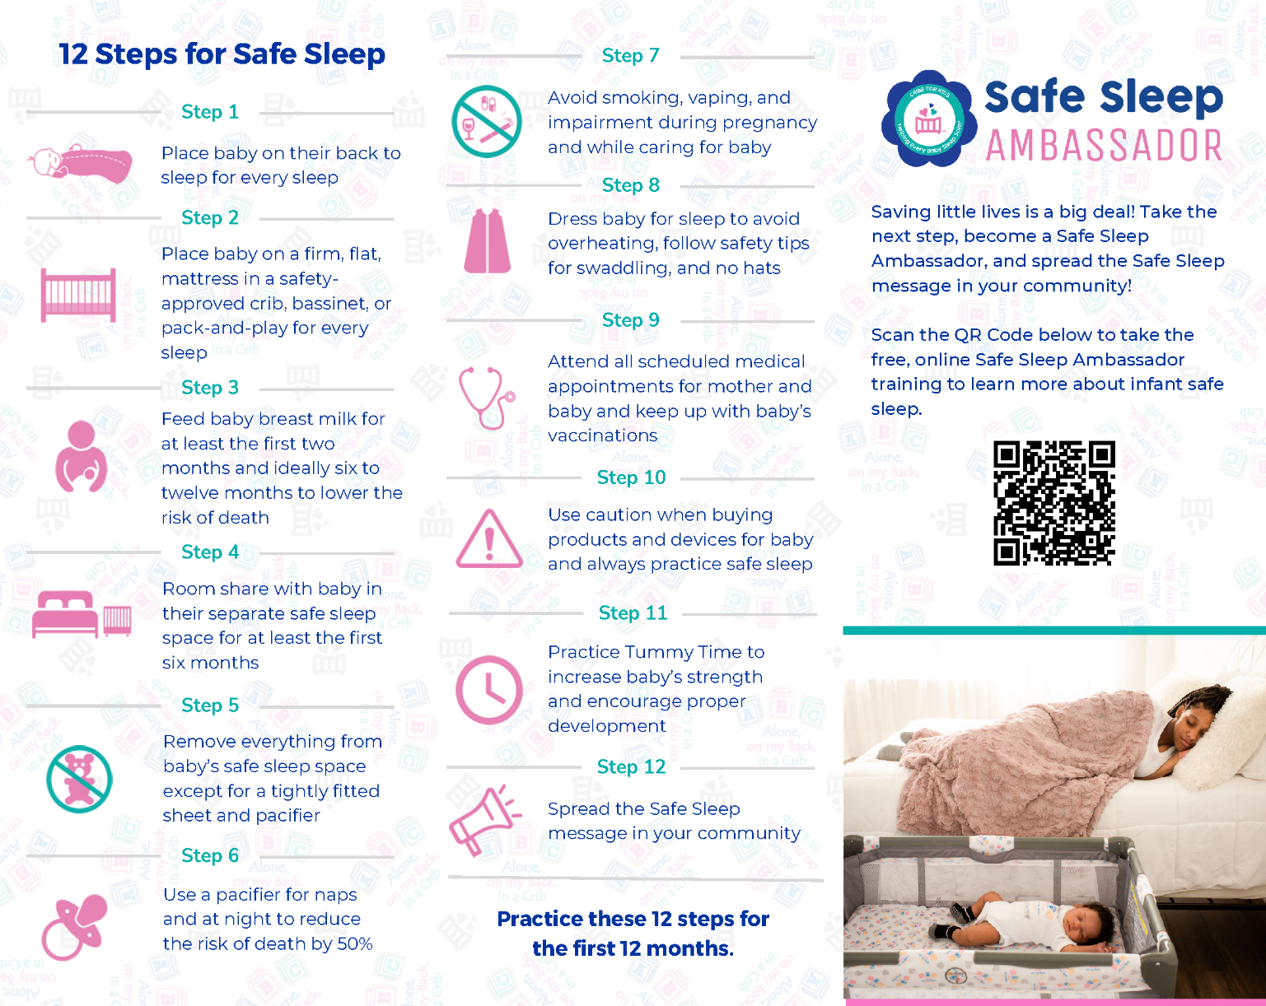

Cytomegalovirus (CMV)
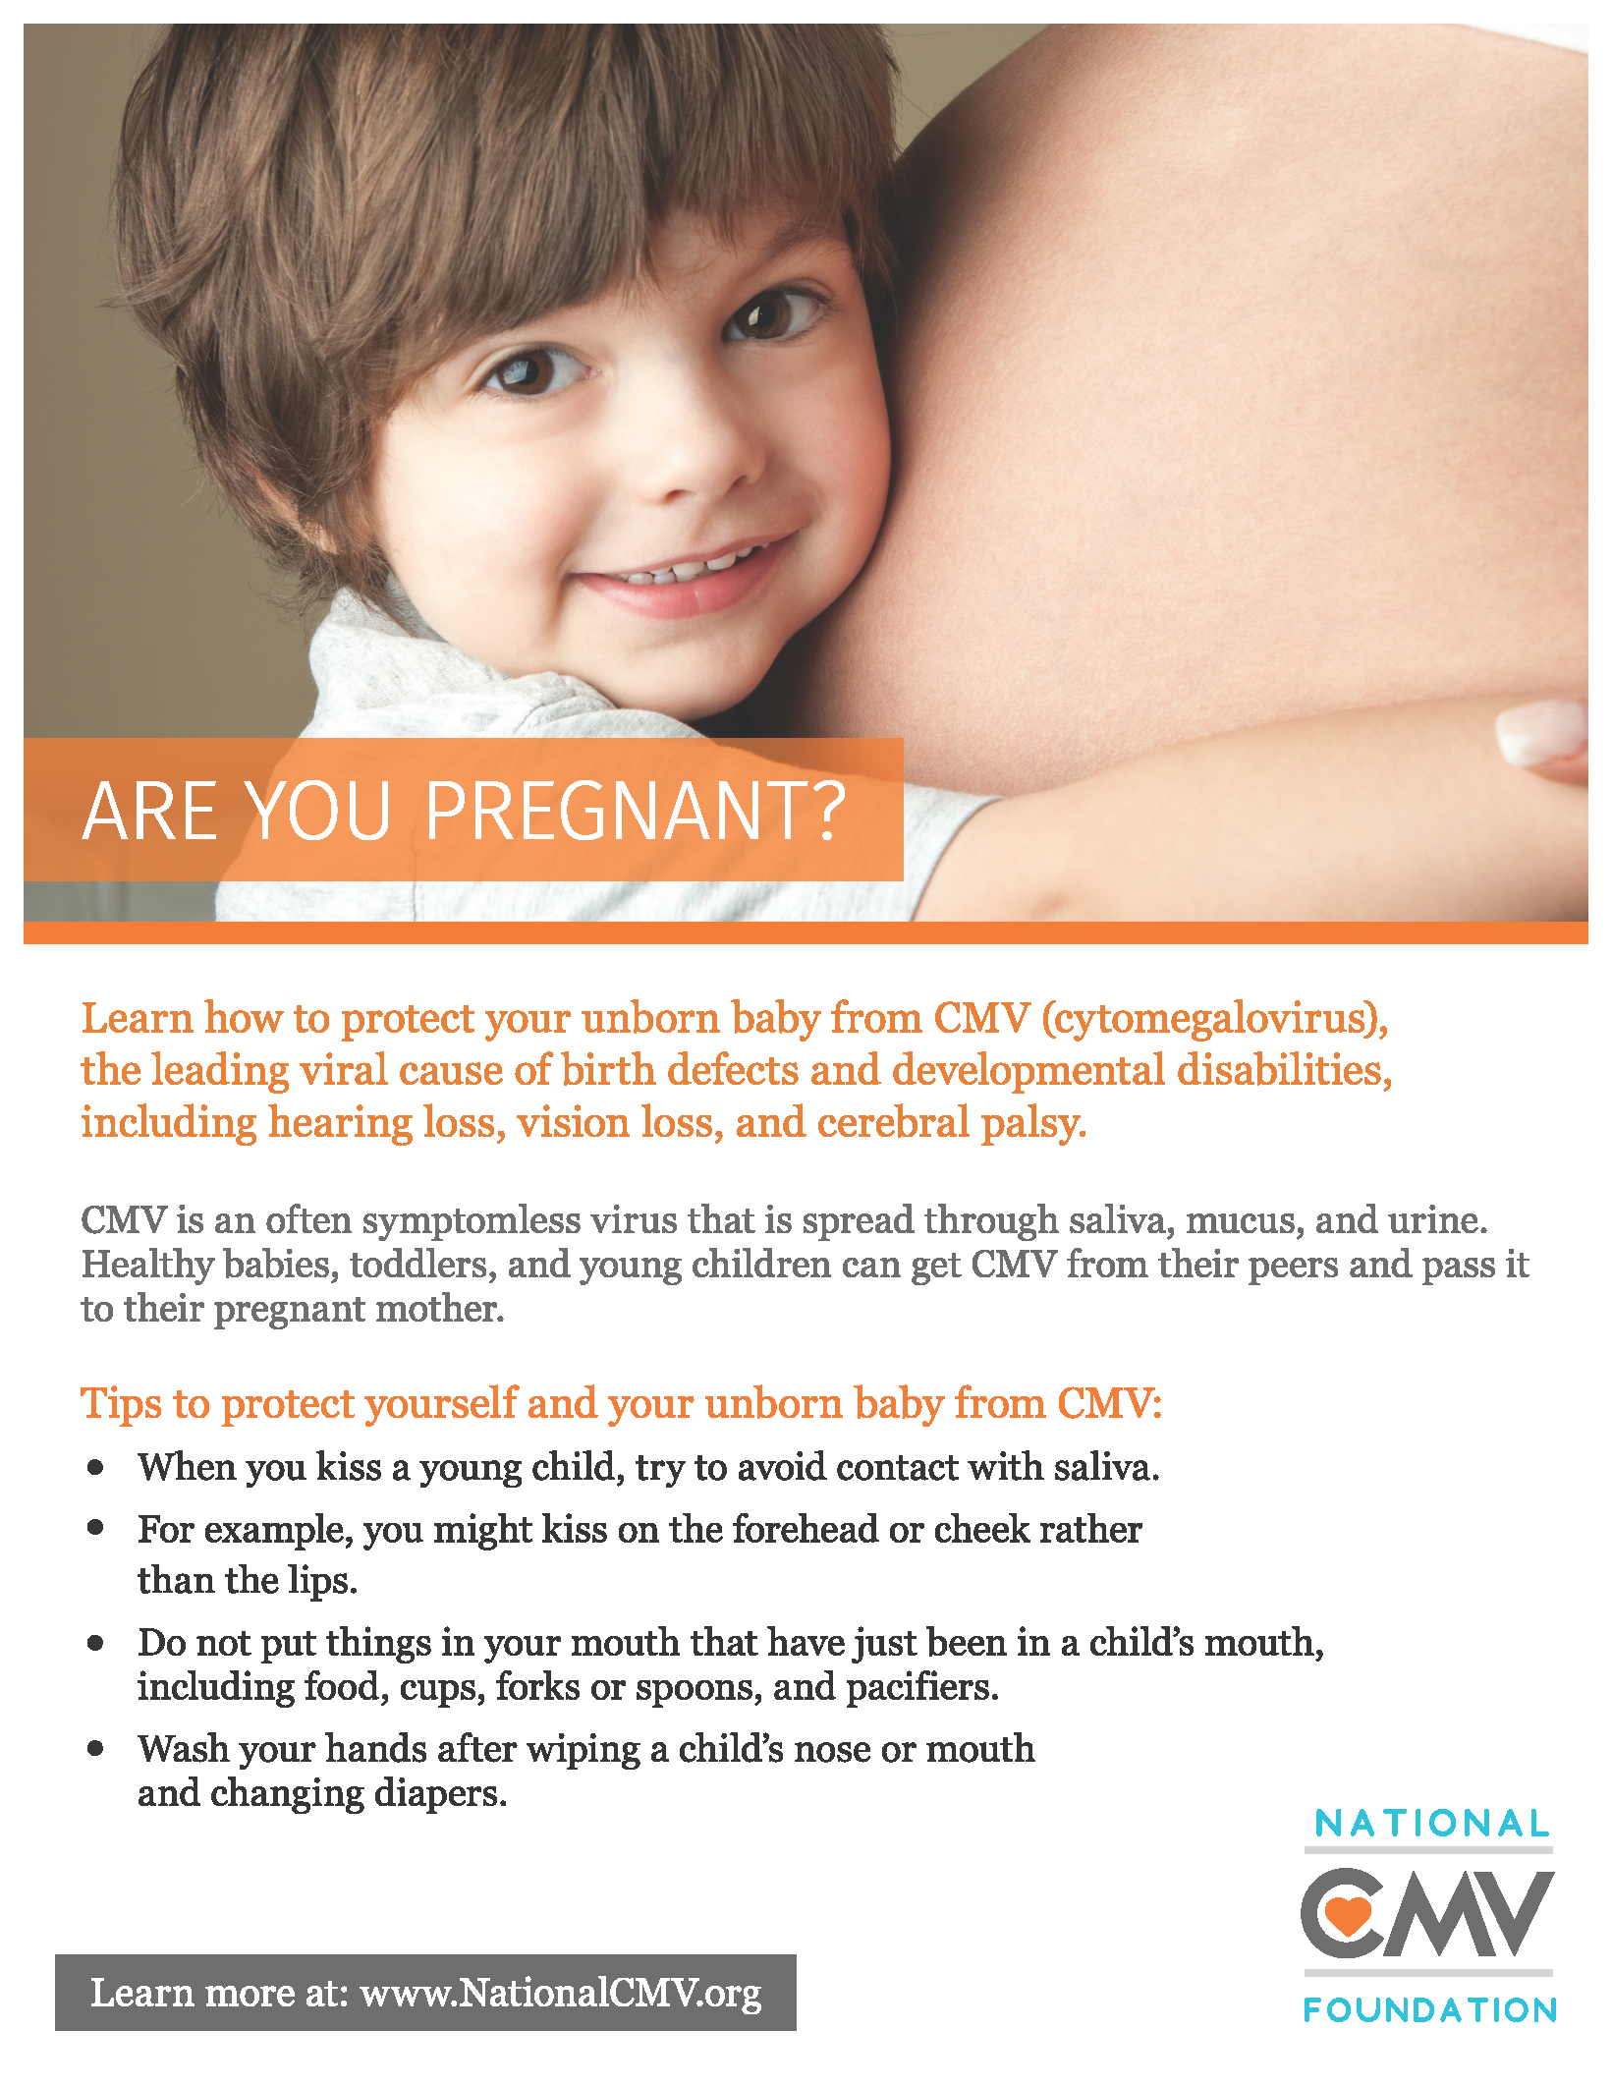

FIRST 5 NEVADA
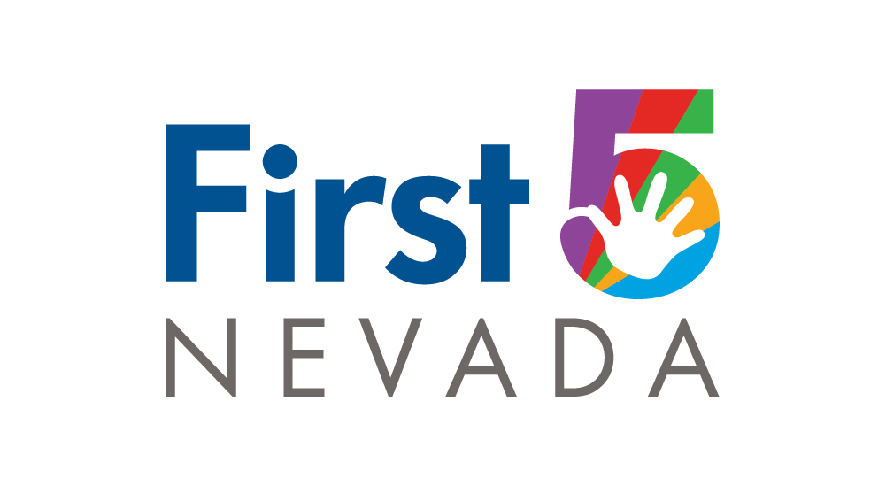

GIVE ME FIVE
The first five years of life are precious. They are also incredibly important for your child’s development and future.
Nevada has programs and funding to help your child get the strong start you want to give them. It takes just five minutes to open a world of opportunity for your child’s first five years. Visit the site at https://www.first5nevada.org.

Heatstroke Safety

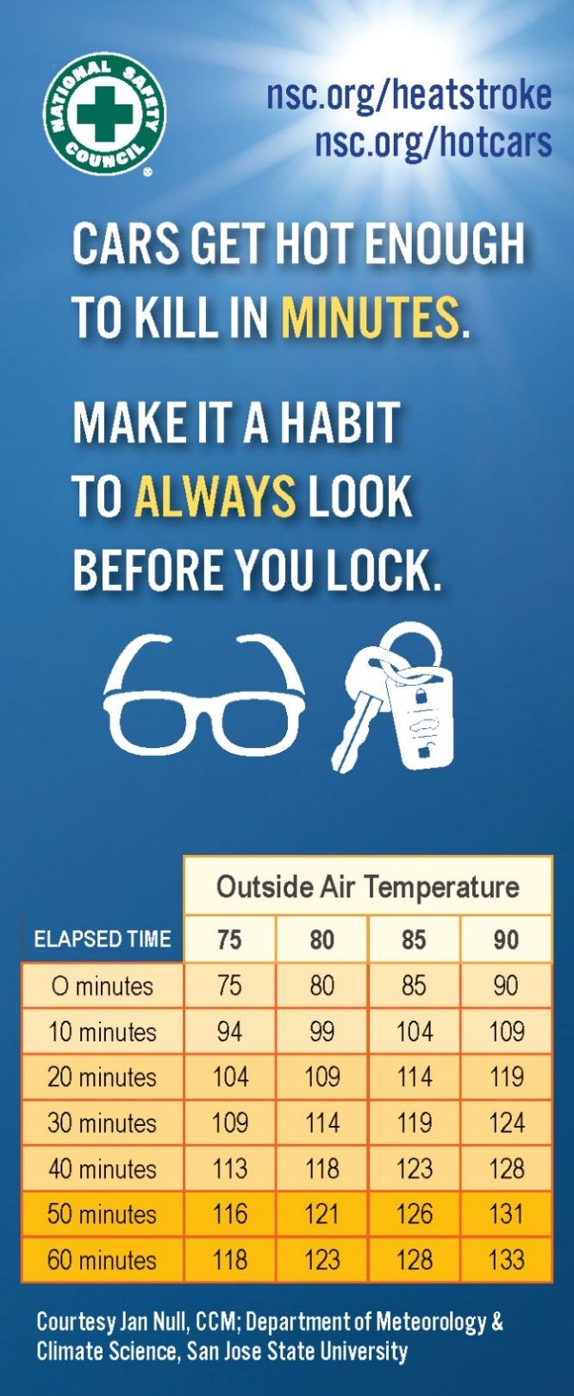

Lead Exposure
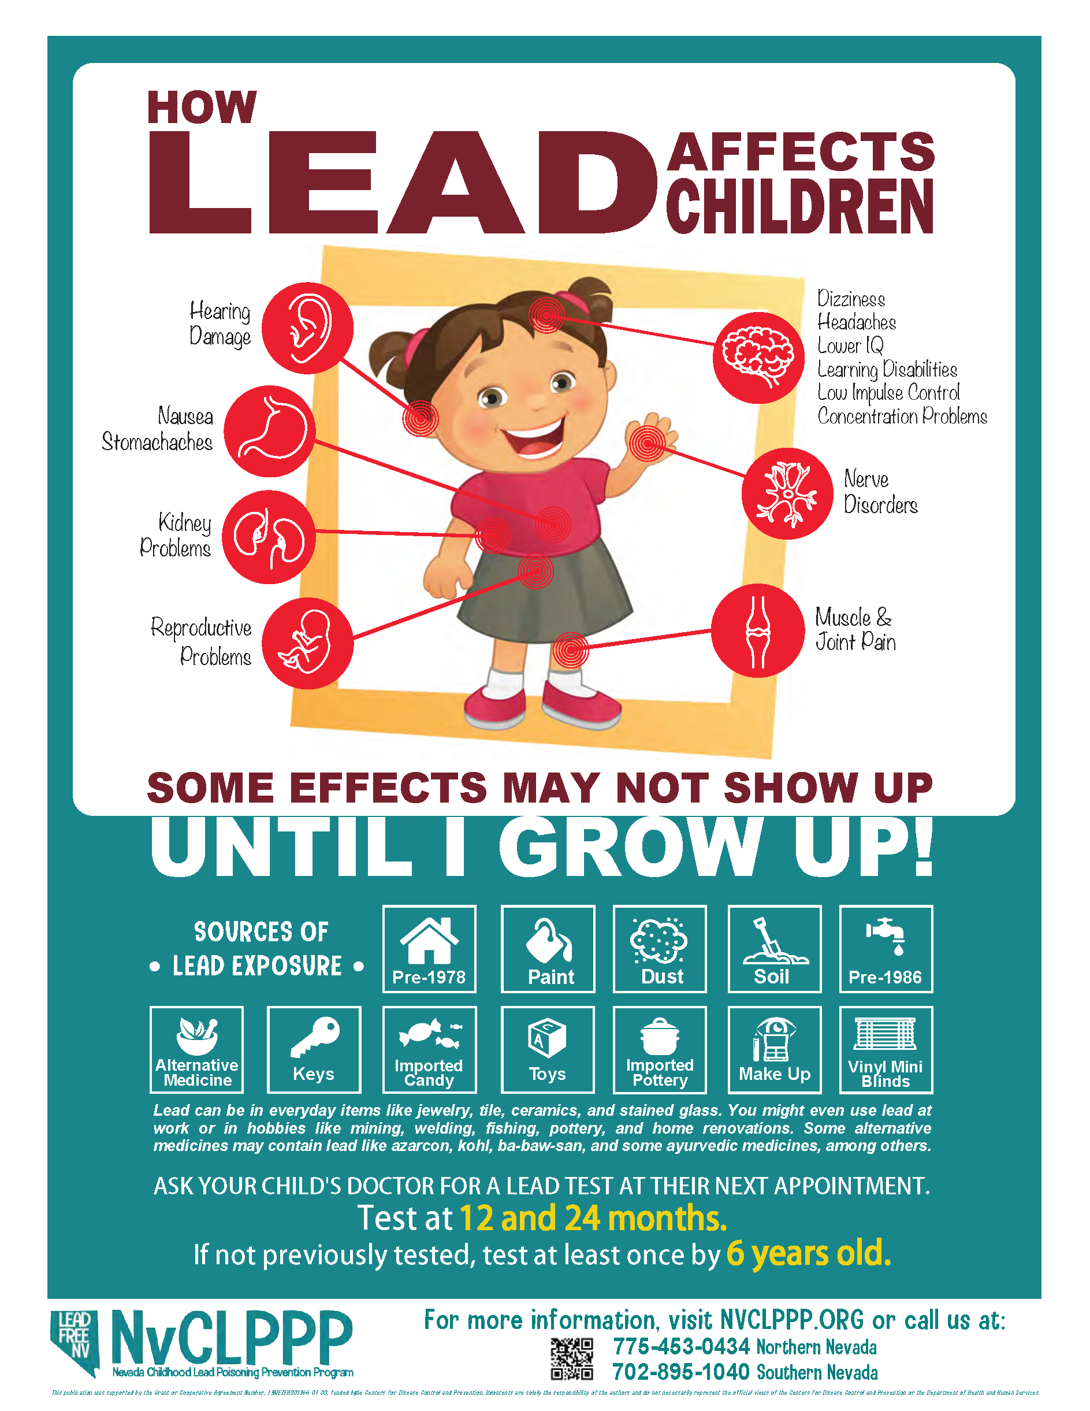

ok Before You Lock!

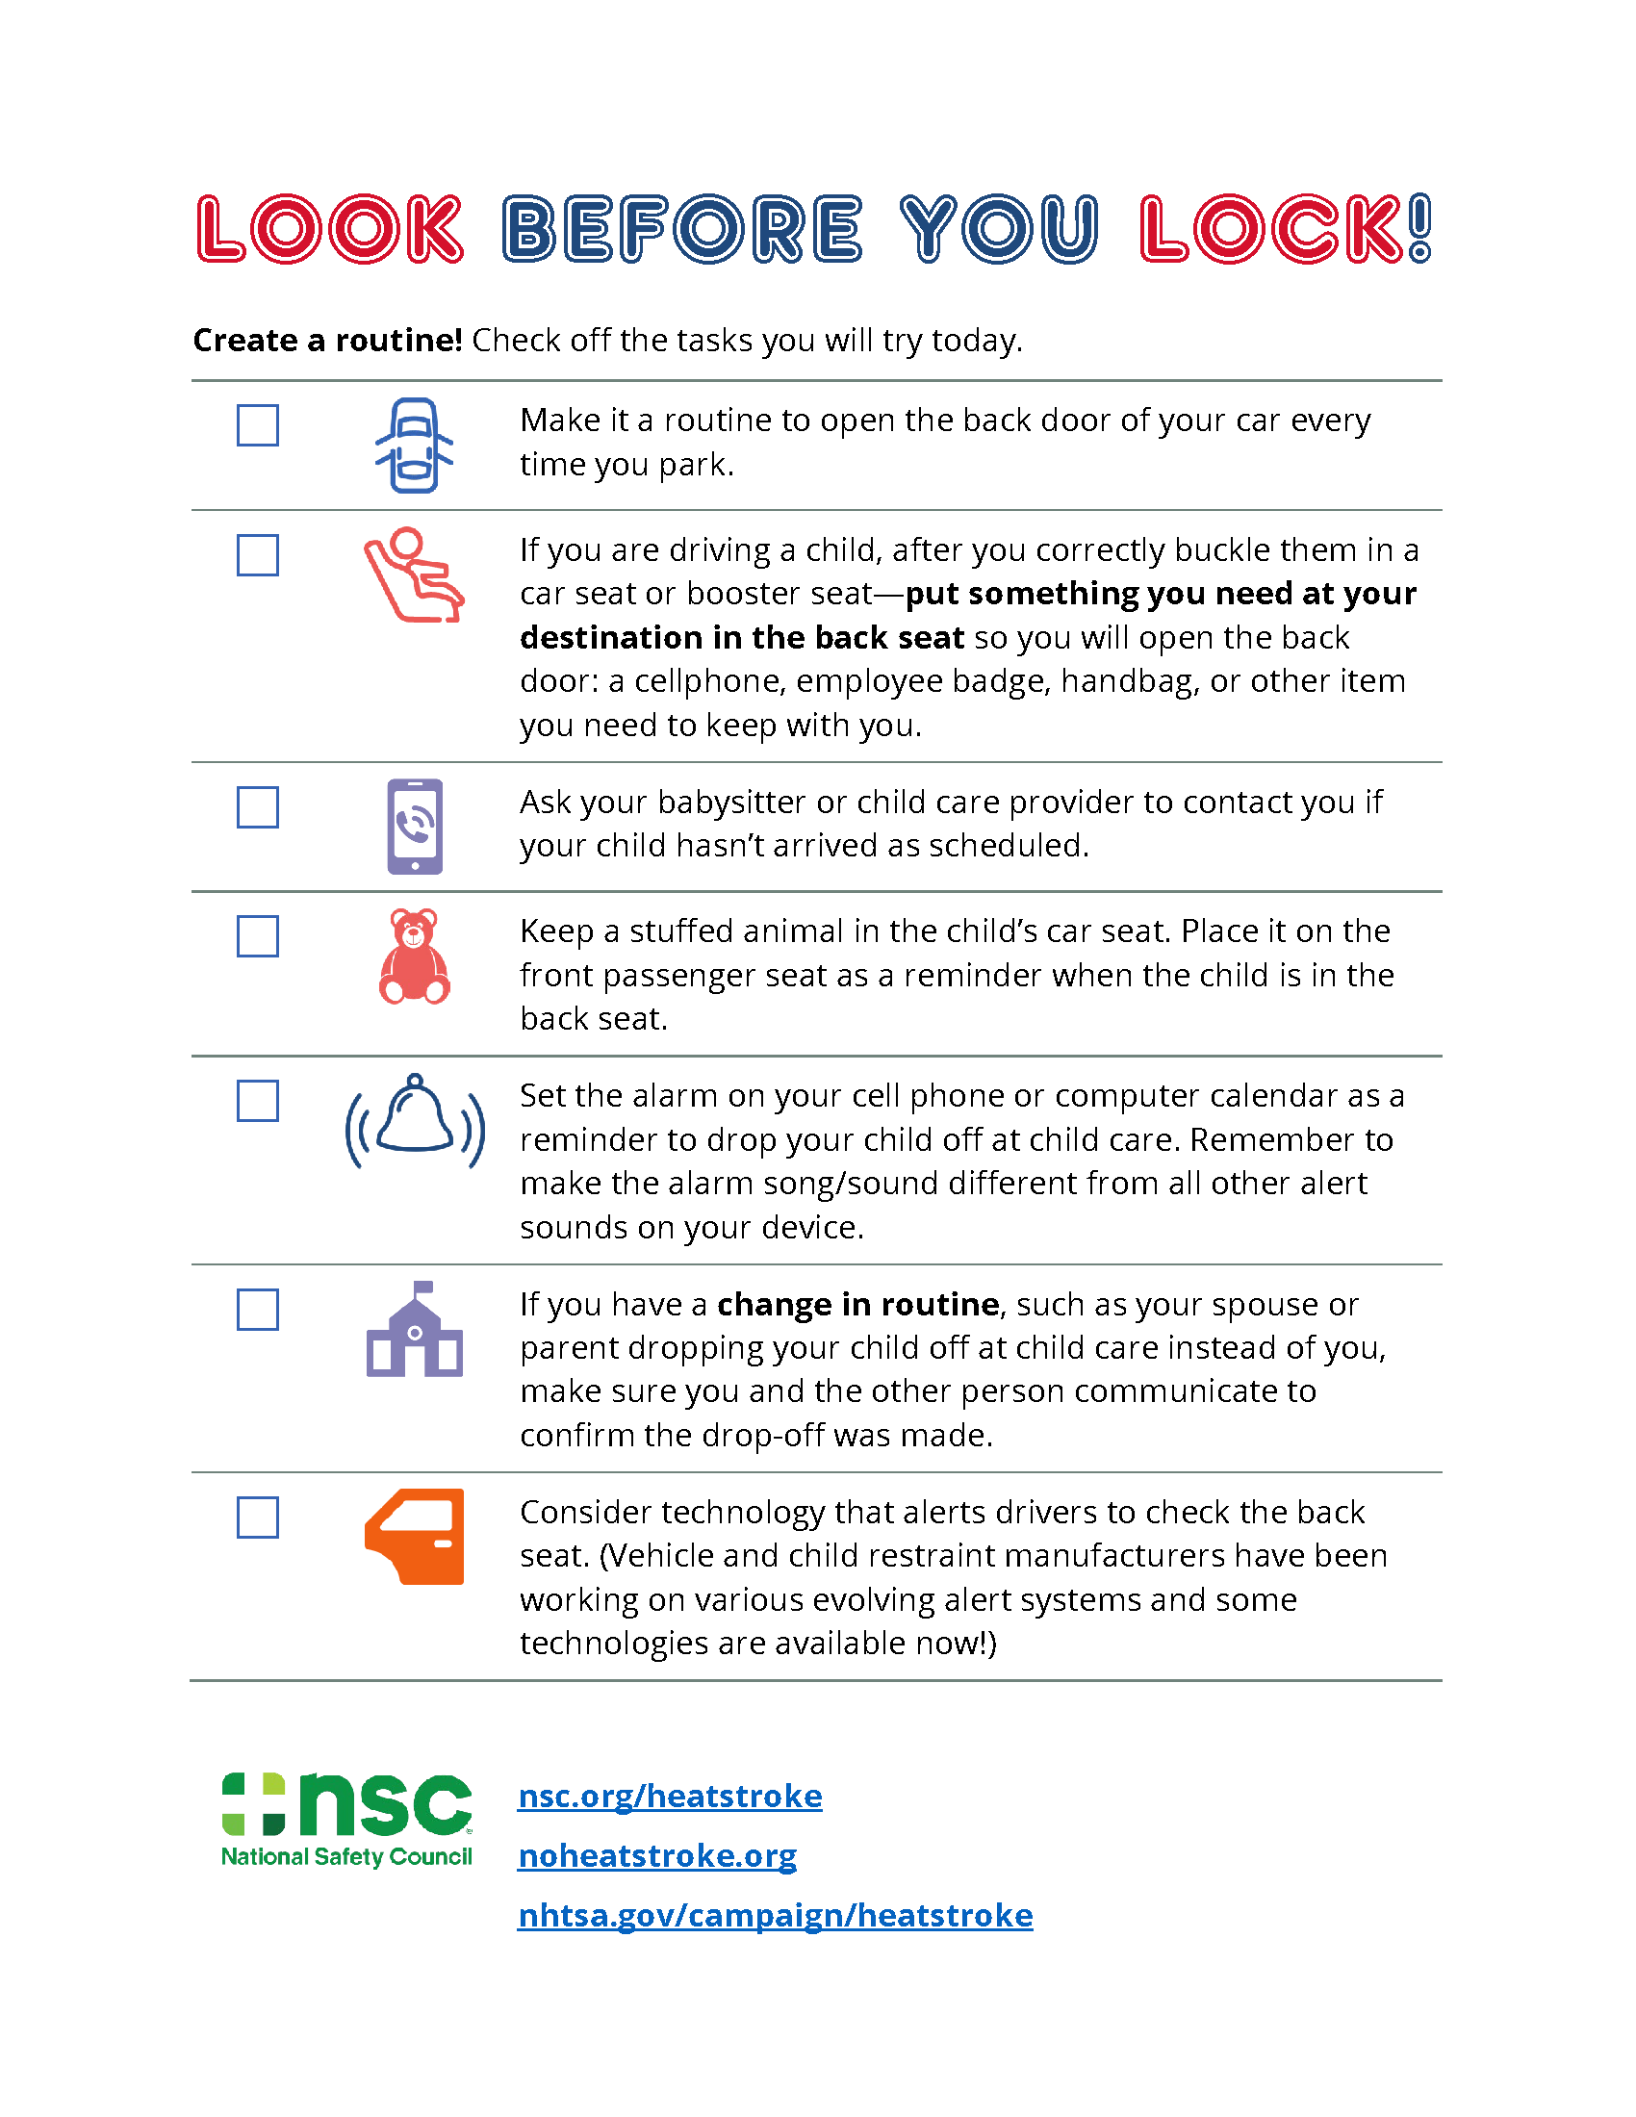

Maternal Hotline
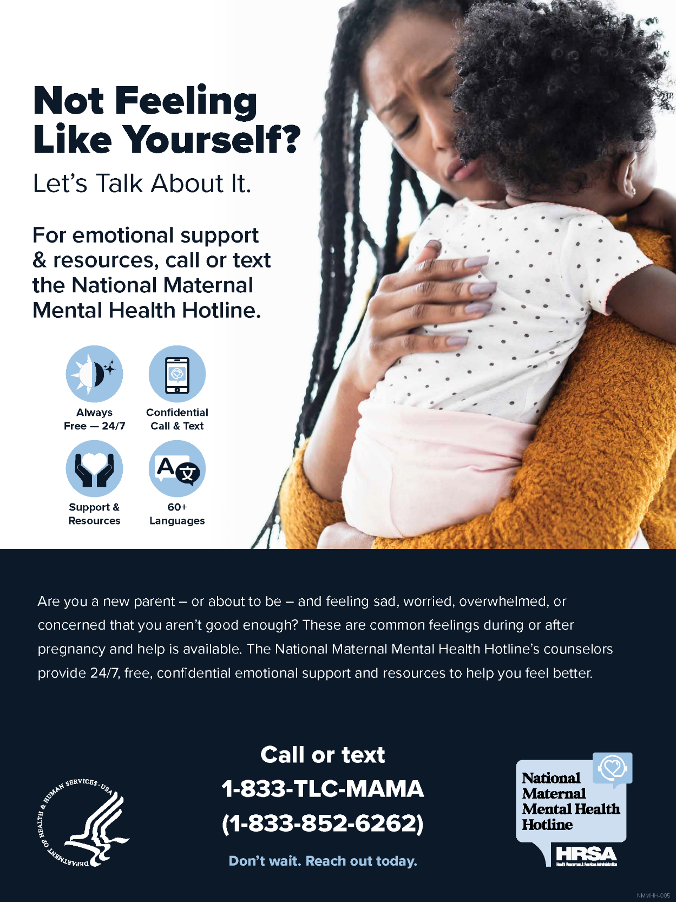

MCH Coalition
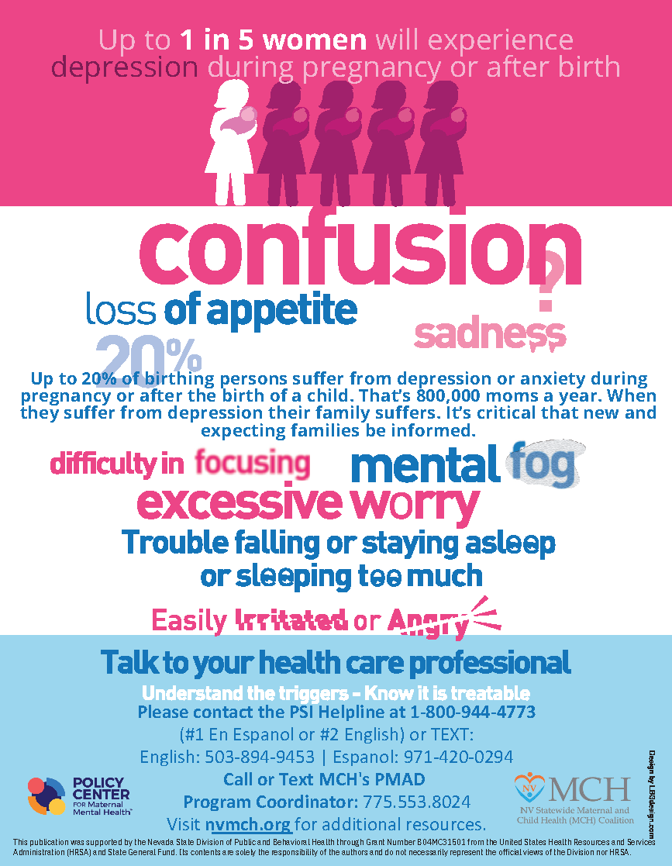

Nevada Breastfeeds
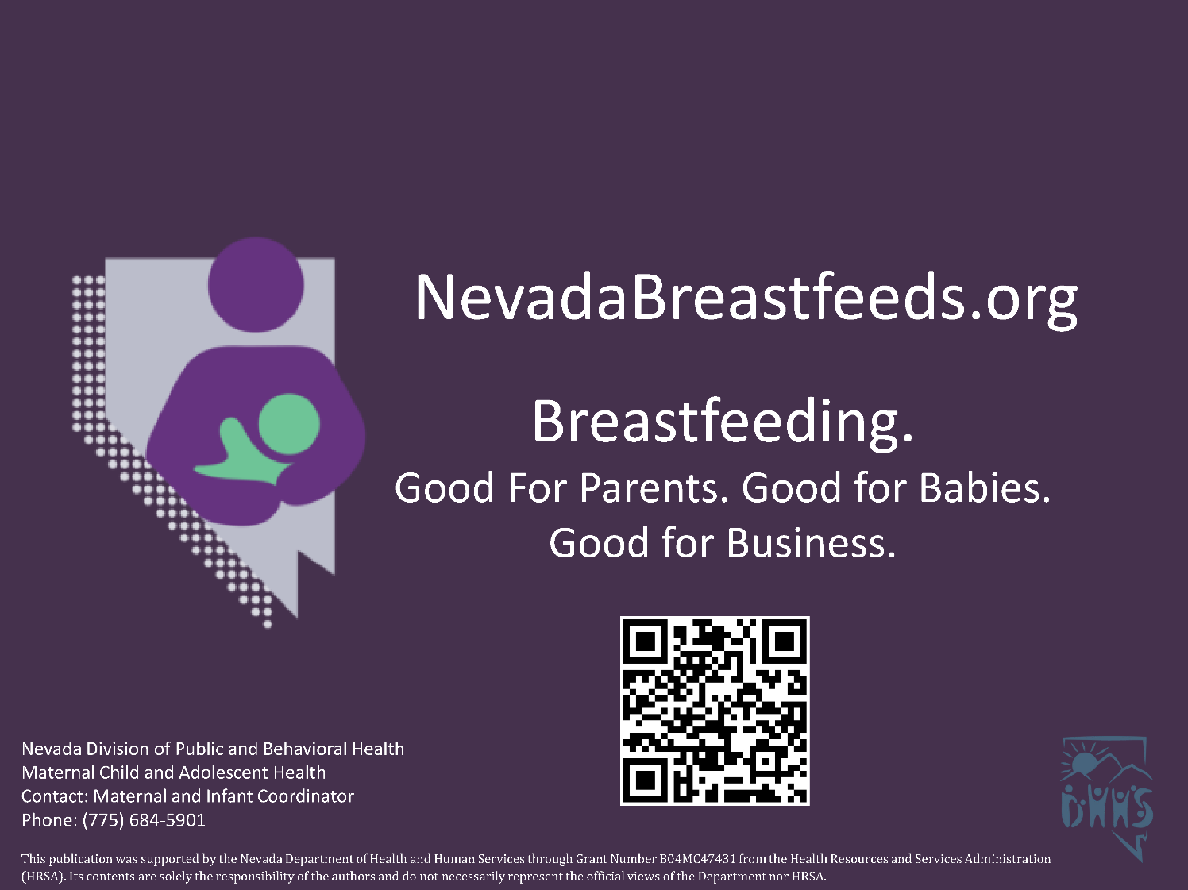

Nevada Children’s Medical Home Portal

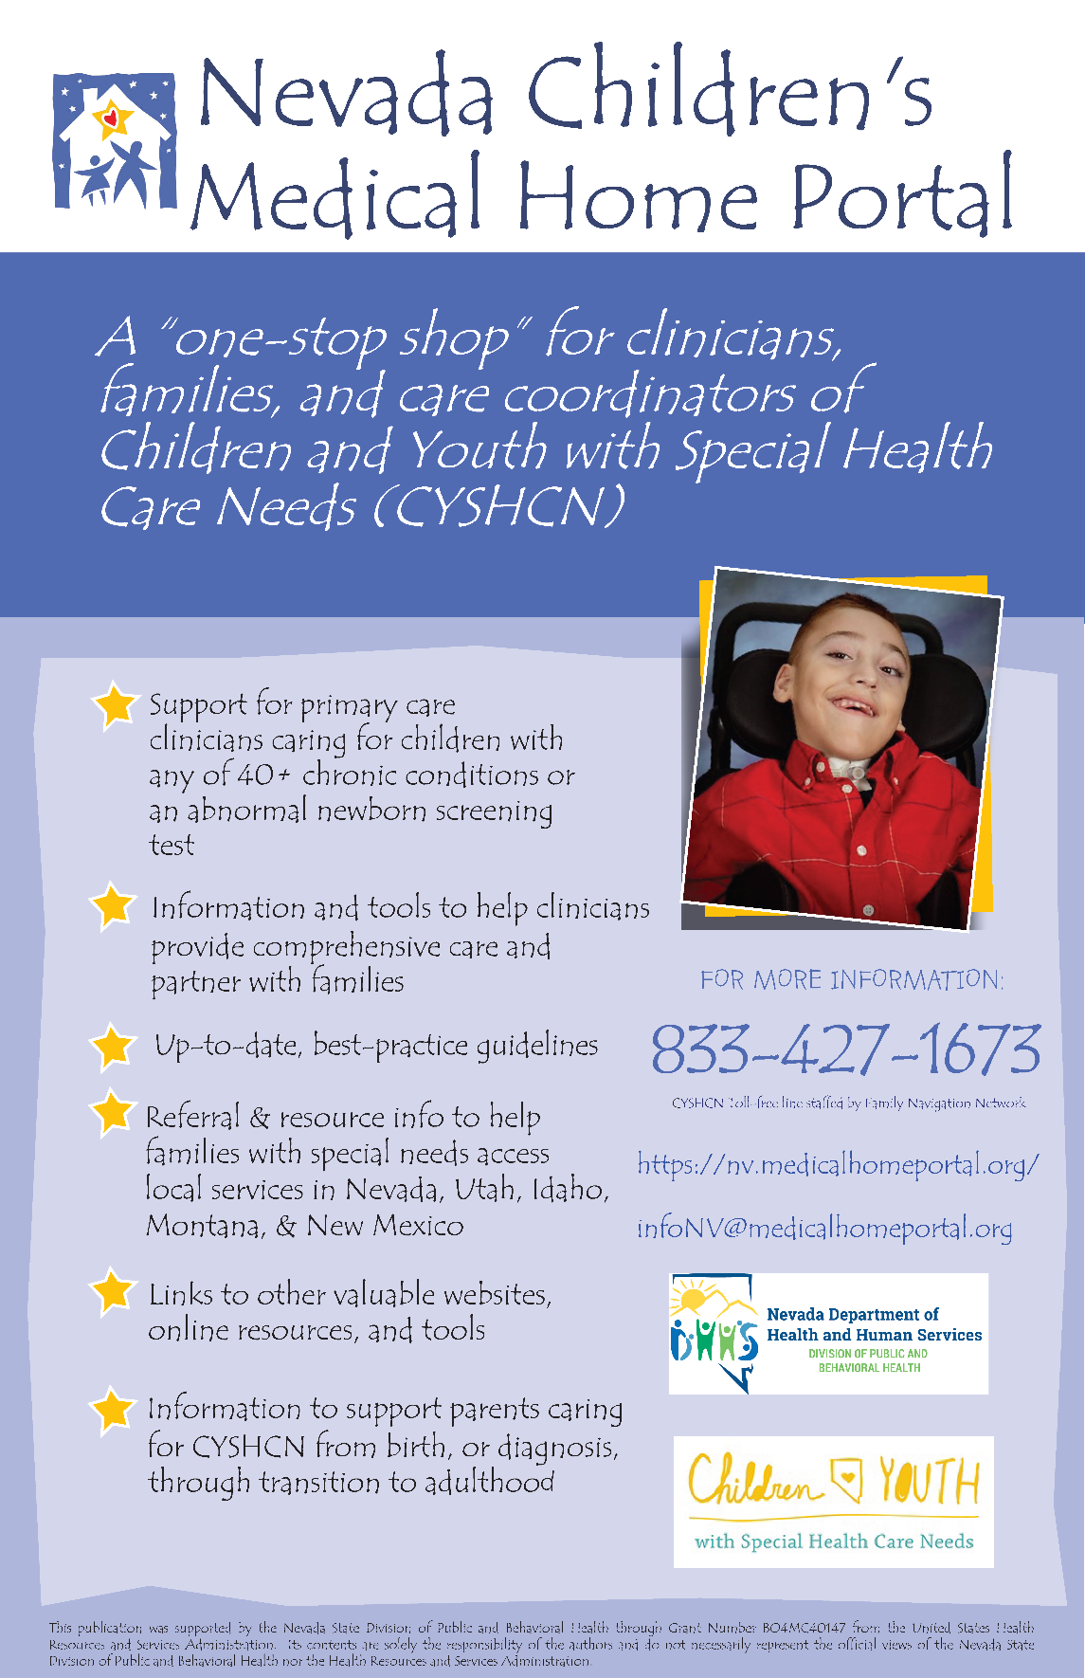

Nevada PRAMS
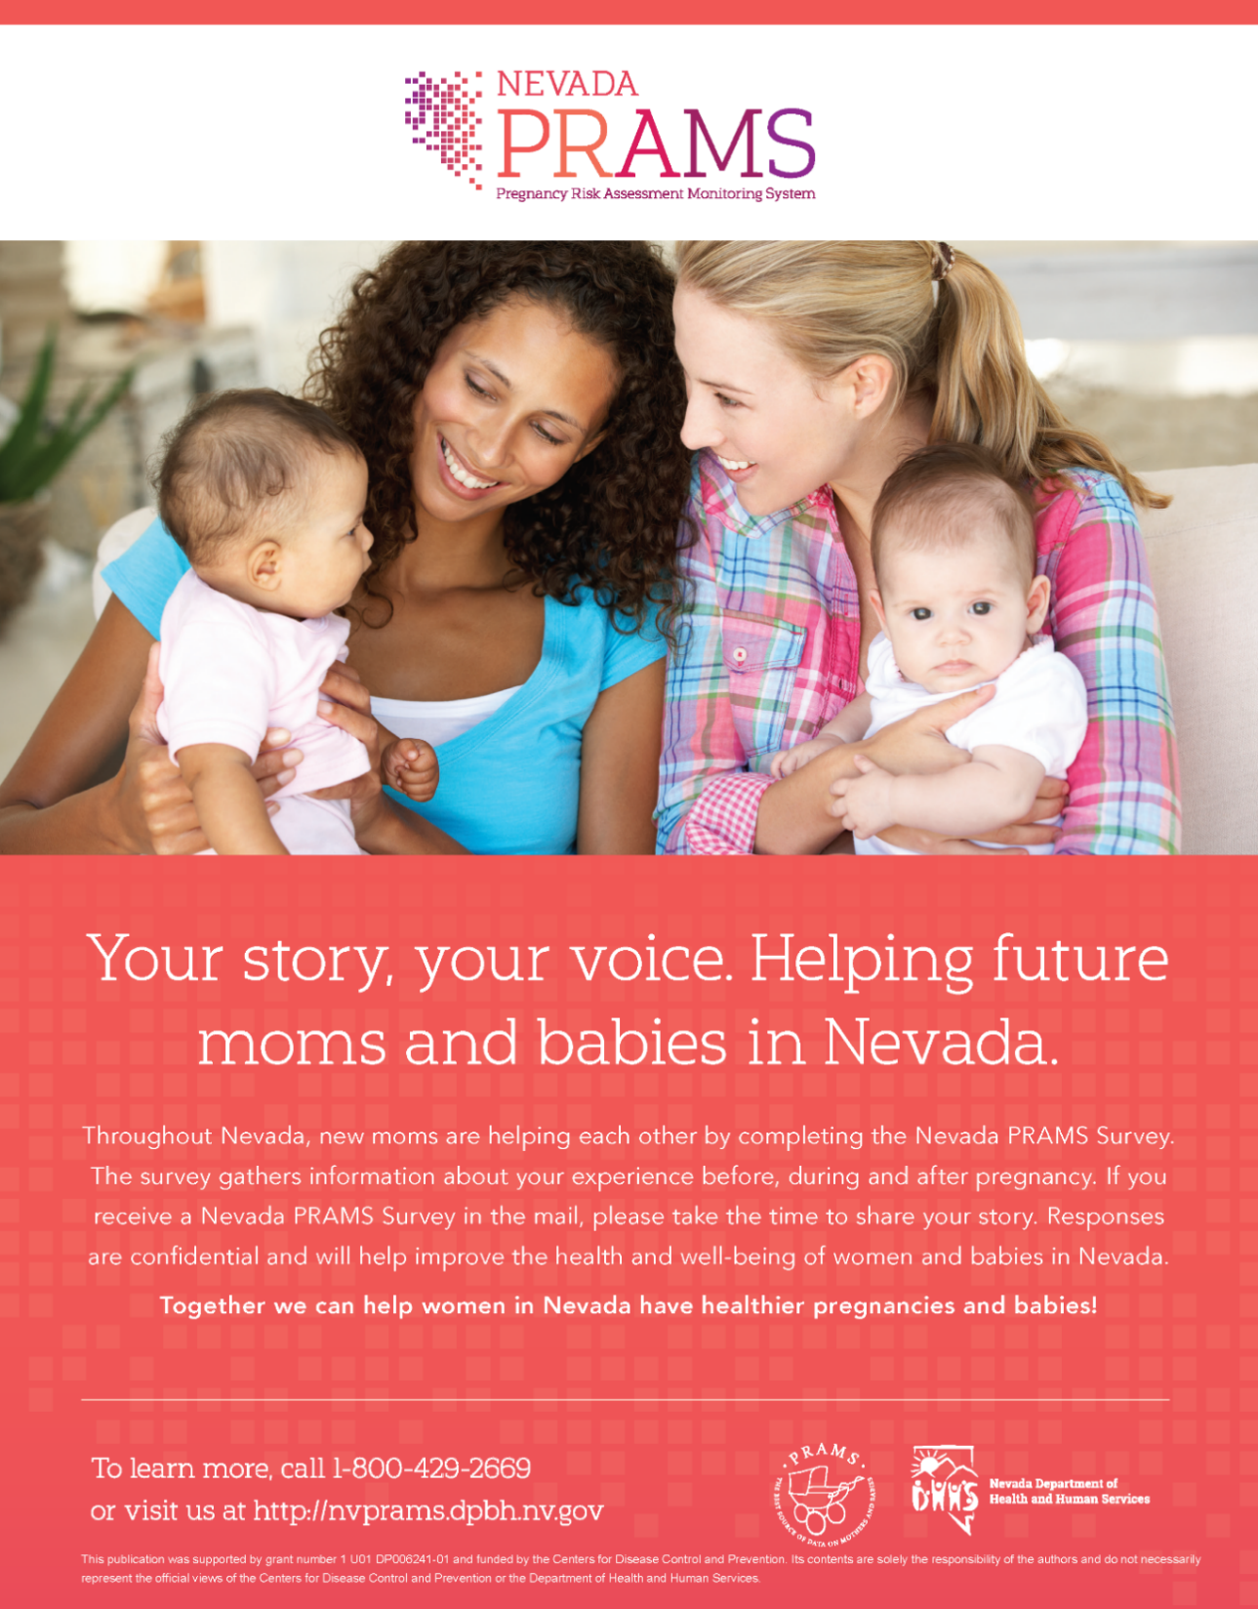

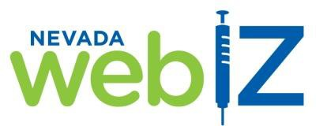
Nevada WebIZ Public Access Portal
Nevada WebIZ is a confidential online Immunization Information System (IIS) used statewide by doctors and nurses to keep track of their patients’ immunizations. Through the Public Access Portal website:
- Parents and legal guardians can print official immunization records for their child(ren) (ages 0 through 17 years), and
- Adult individuals (ages 18 years and over) can print an official immunization record for themselves.

This is an official record and can be used as proof of immunization for school entry, summer camp, employment, etc.

Six Easy Steps to Finding a Record Through the Public Access Portal
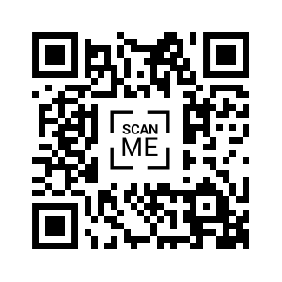
- Ask your doctor to update your email address and cell phone number on your and/or your child(ren)’s Nevada WebIZ record.
- Visit the Public Access Portal at:

https://izrecord.nv.gov

- From the dropdown in the upper left corner, select your language preference (English or Spanish)
- Select whose record you are seeking (Me or Dependent), then enter the Last Name, First Name, Date of Birth, and Gender of the person whose record you are searching for.
- Verify your identity by selecting where you would like the Access Code sent (Mobile Phone or Email Address) and enter the mobile phone number or email address.
- Enter the Verification Code in the text box on the next screen and select Verify.
- Download and save/print the Official Immunization Record, COVID-19 Record, or COVID-19 QR Code (Adobe .PDF format) to have for your records.

Please feel free to contact our Help Desk at 775-684-5954 or via email at izit@health.nv.gov if:
- Your doctor’s office is not entering immunizations into Nevada WebIZ (Nevada law requires that all immunizations given in Nevada be stored in Nevada WebIZ),
- You experience any trouble accessing the Public Access Portal, or
- You have any questions or concerns.

Learn more about Nevada WebIZ by visiting:
http://dpbh.nv.gov/Programs/WebIZ/WebIZ_-_Home

Post-Birth Warning Signs
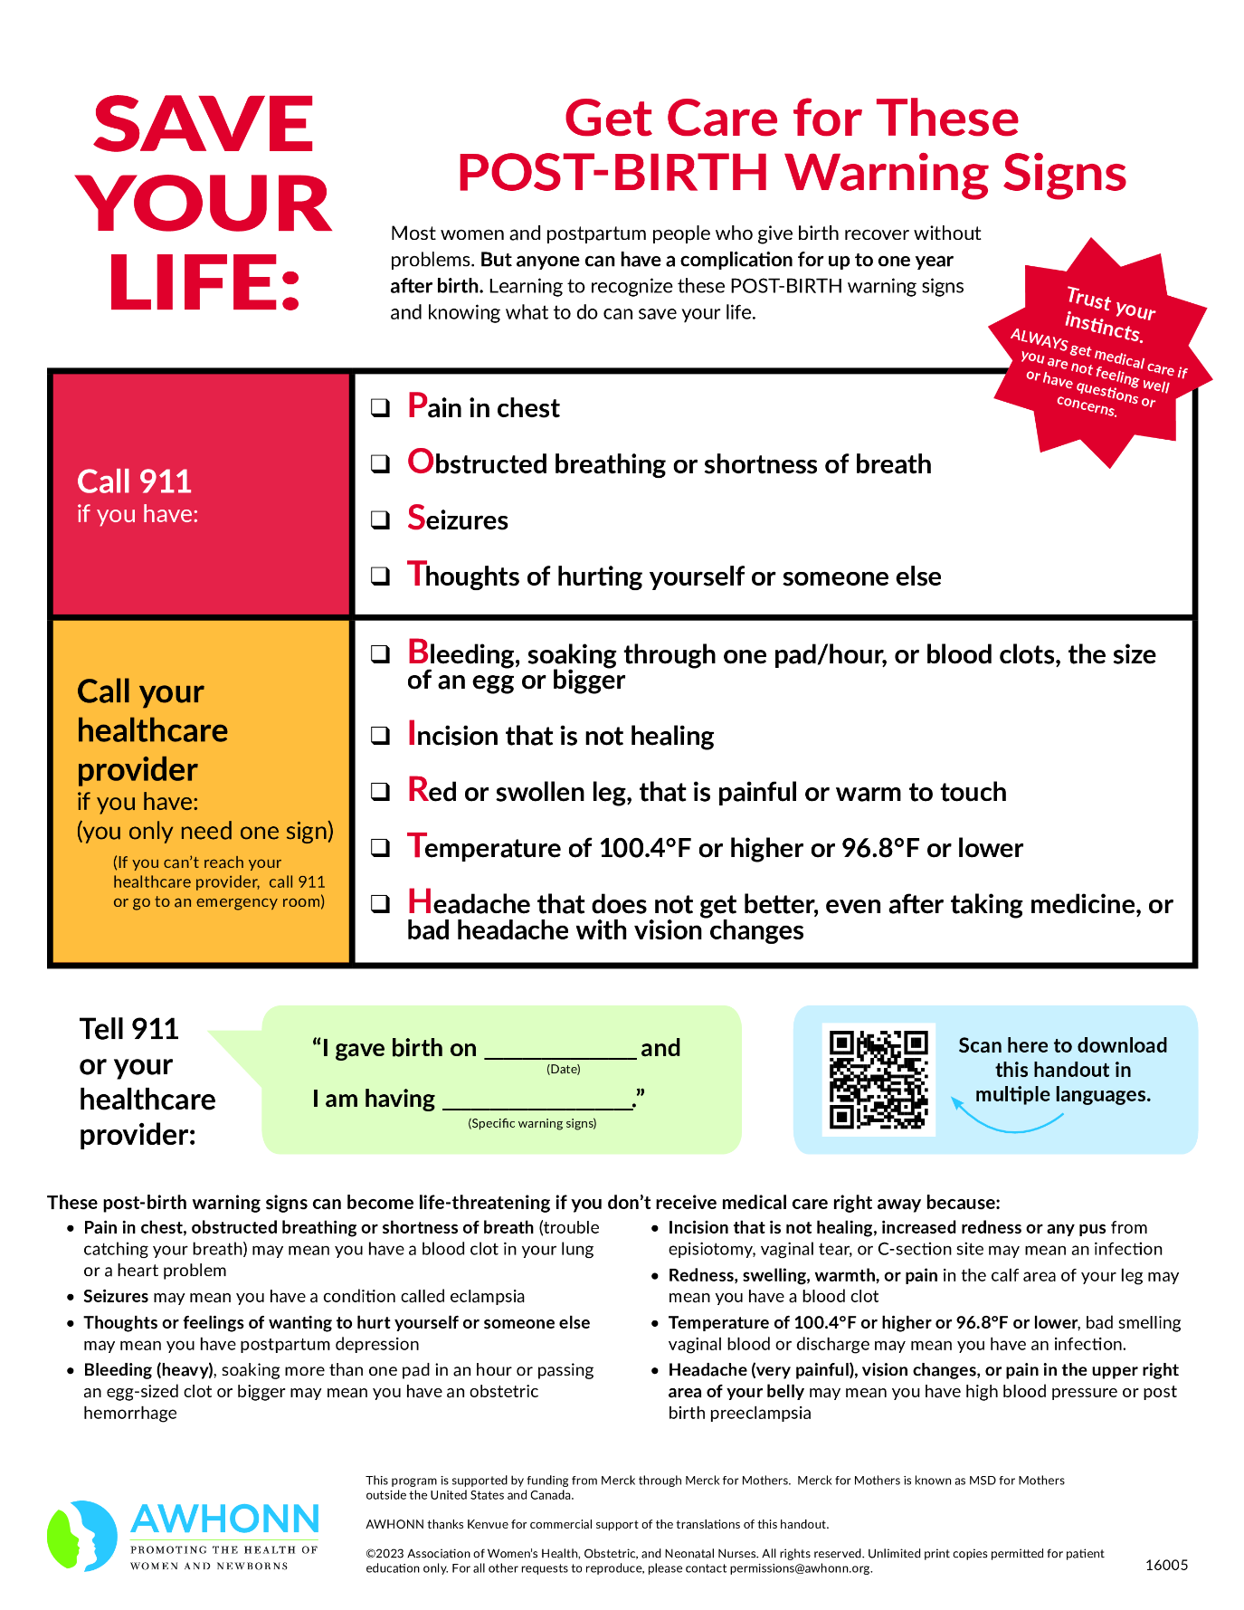

Recommended Vaccinations

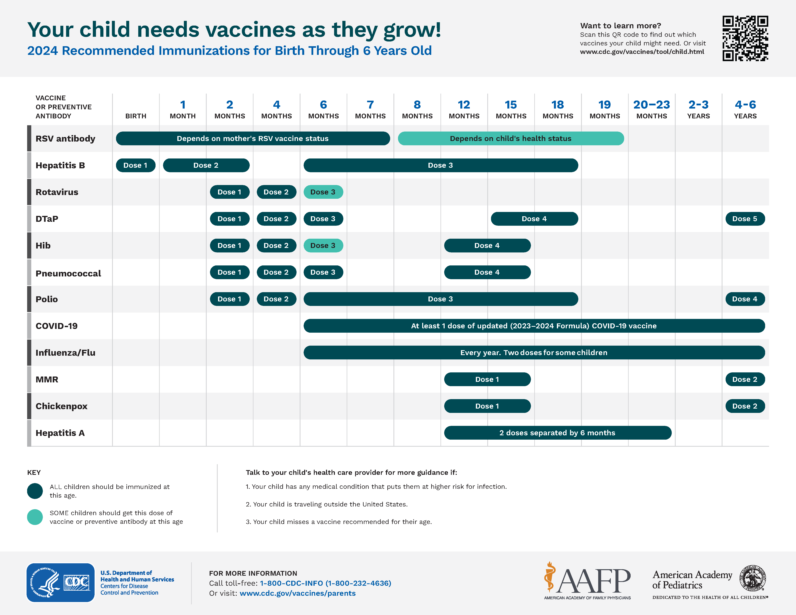

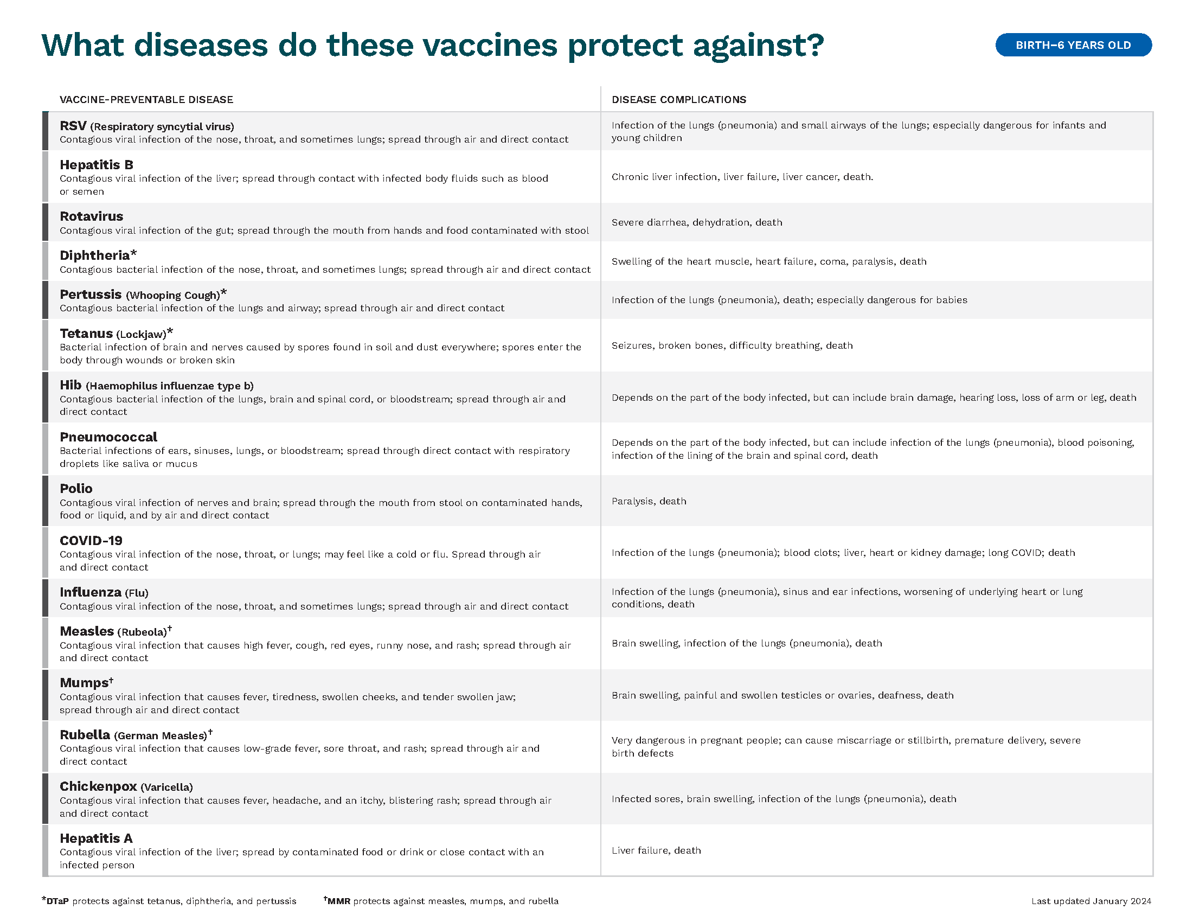

RSV- Infants and Young Children
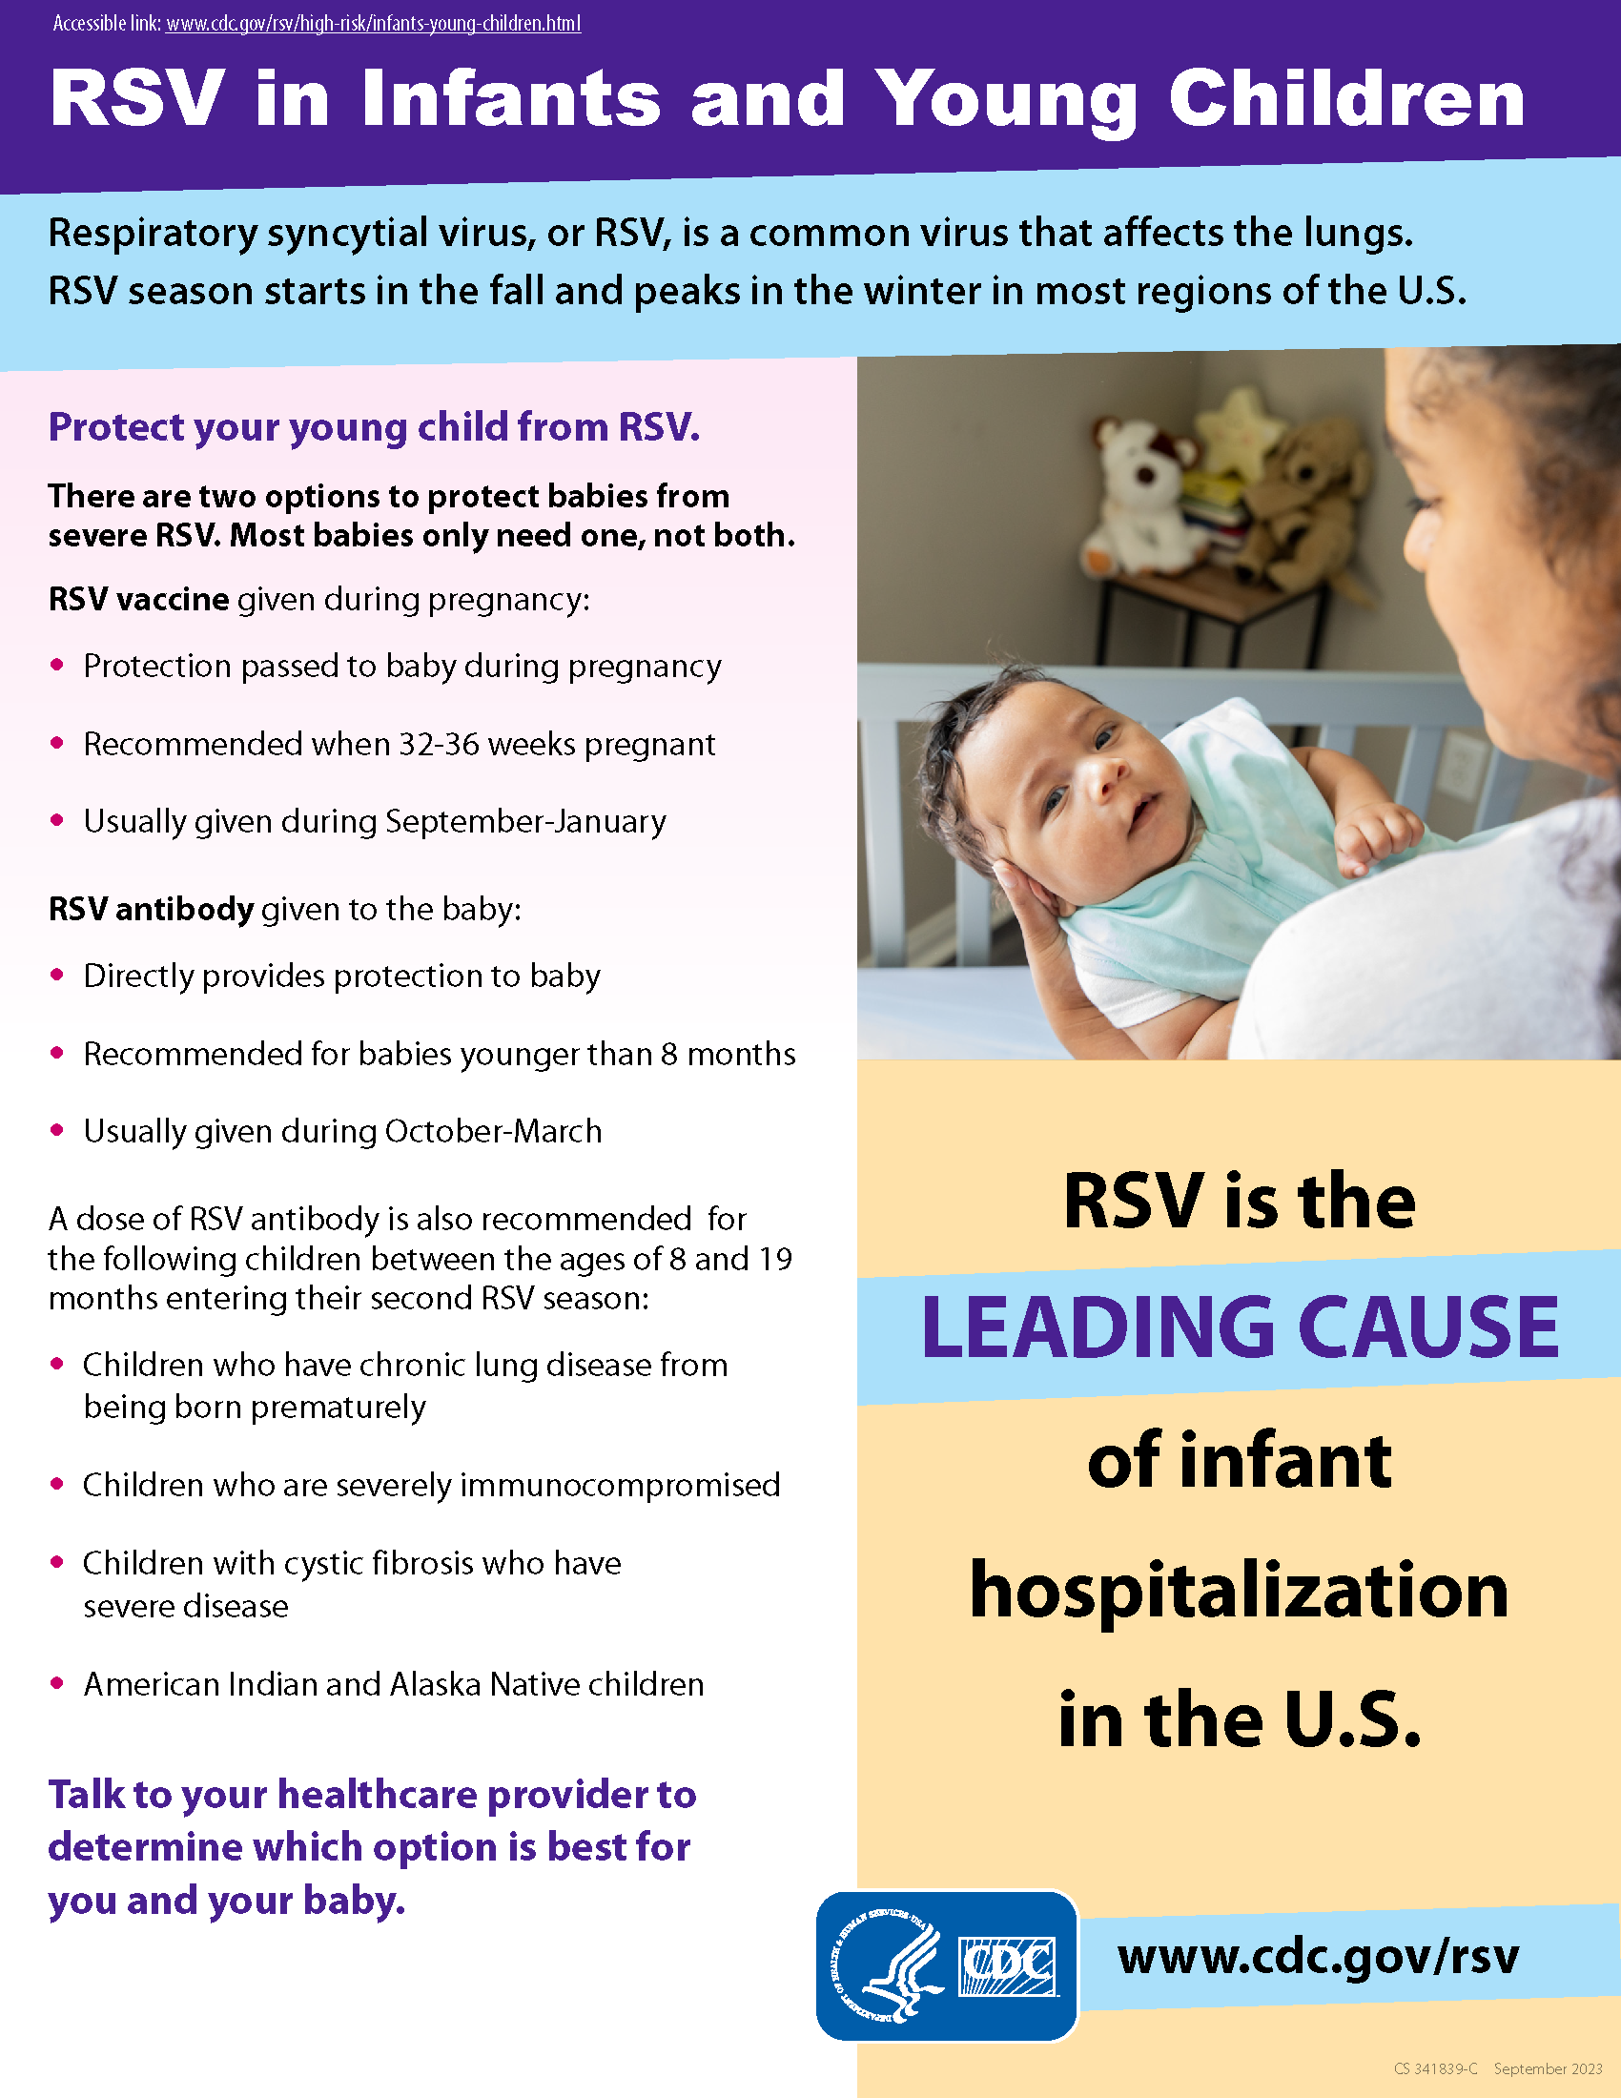

Sober Moms, Healthy Babies
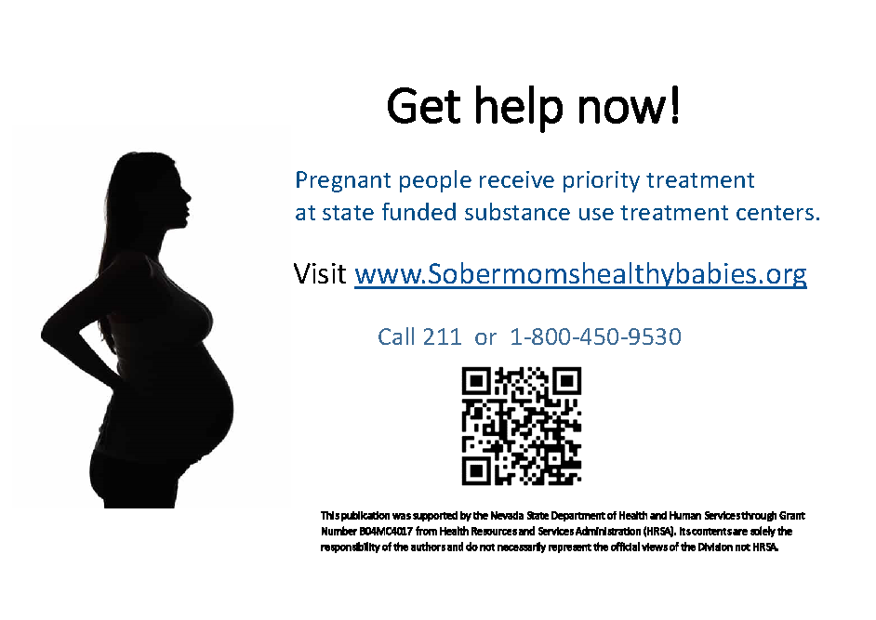

Vaccines for Children (VFC)
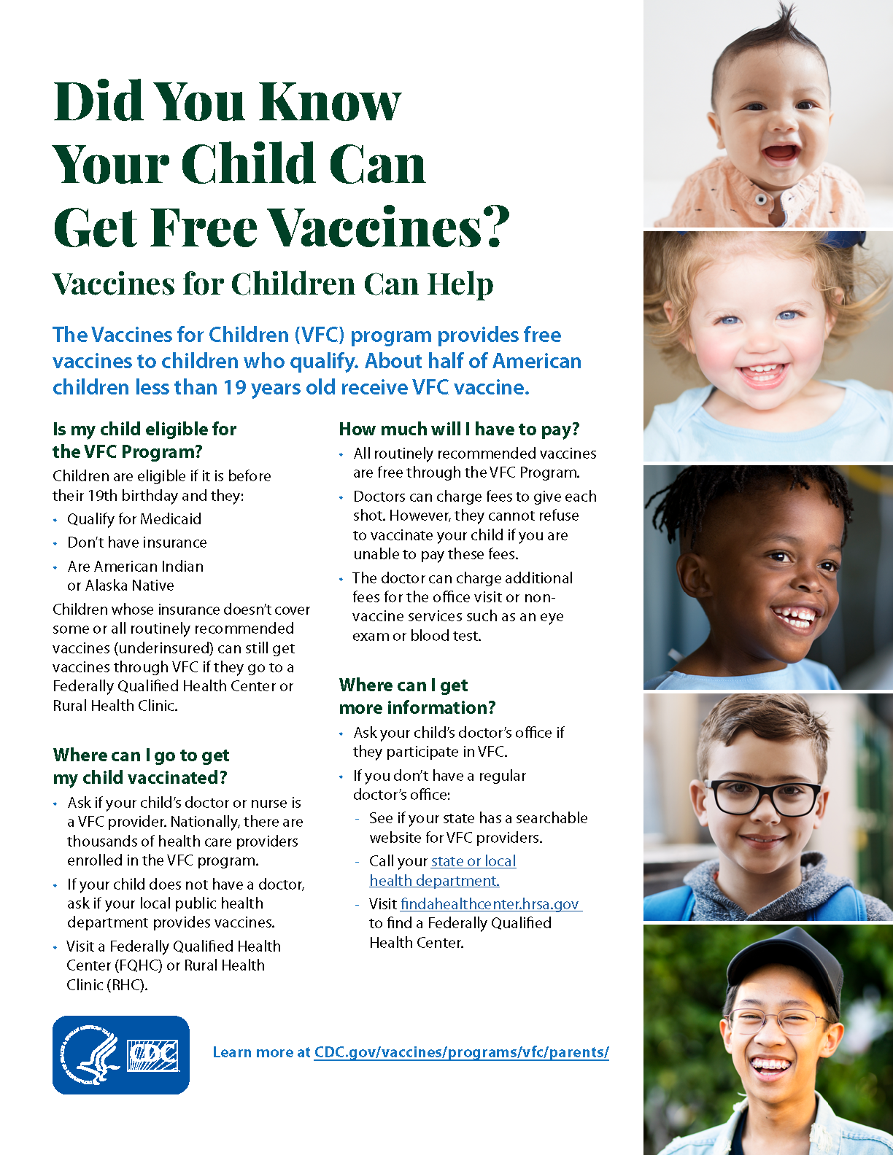

Water Safety Tips for New Parents
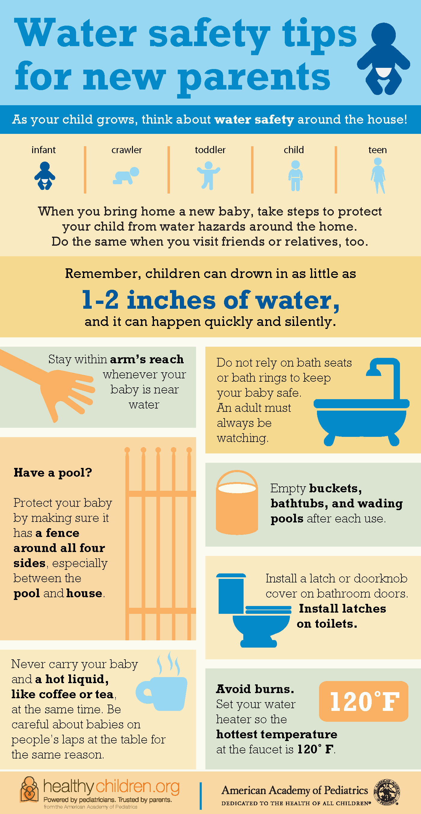

WIC
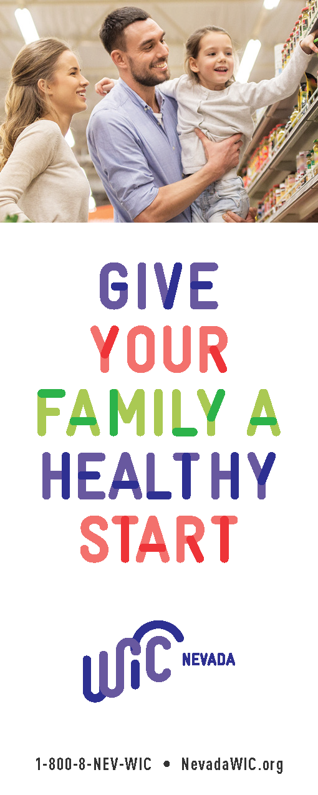

Additional Resources

Visit the links below to access helpful information and resources for you and your newborn:

Family Navigation Network
Medical Home Portal
Nevada 211 Health and Human Services | Helping Nevadans
or Call 2-1-1 or 1-866-535-5654; Text your zip code to 898211

Please explore this guide and reach out if you have questions or to share your feedback. Your input will help to continually improve the usefulness of this resource guide to better serve the State of Nevada.
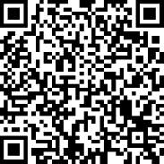
To provide feedback regarding this new resource, please scan the QR code to open the survey:

